Process Meetup

Table of Contents
DURING ORGANISATION 1
1-WEEK BEFORE THE MEETUP 1
MONDAY before meetup 2
1-DAY BEFORE THE MEETUP 2
ON THE DAY 2
DURING THE MEETUP 2
AFTER THE MEETUP 2

DURING ORGANISATION

- Arrange with the speaker and the event date, and ask him/her to provide content
- Prepare the Meetup page
- Advertise the Meetup
- Inform the speaker that the event is arranged (share the Meetup link)
- Inform ASVPM Team
- Keep communication with the speaker
- Monitor the Meetup page and # of attendees
- Promote the event via email, slack, and LinkedIn every week
- Create a folder for the speaker in our cloud server (use an FTP client like FileZilla). Login to the cloud server using the login credentials:
- HOST: asvpm.org
- USER NAME: meetup
- PASSWORD: Team4#Meetup!
  - Make sure the name of the folder does not have spaces, i.e. “Name_Surname” and save the form the speaker returns with the marketing content there.

1-WEEK BEFORE THE MEETUP

- Contact the speaker again to remind him/her.
- Prepare the “plan b” Zoom link (do not add anyone as a co-host to reduce the confusion).
- Contact Meetup attended and remind them about the session.
- Contact the Meetup followers that have not replied to the event.
- Remind (ASVPM) Scrum Masters to remind their team members.
- Prepare ASVPM introduction & speaker introduction to open Meetup.
- Meet with ASVPM Meetup Team for last-minute arrangements.

MONDAY before meetup

- POST & pin & bookmark in the (Slack) general channel a post about this session.
- Ask anyone who is attending the leadership meeting to remind others about the Meetup.

1-DAY BEFORE THE MEETUP

- Remind (via the Meetup page) about the Meetup 1 day the Meetup to attendees only.
- Promote the Meetup for the last time on LinkedIn
- Post in (Slack) Team chats (in Slack) to remind all team members.

ON THE DAY

- Share with the ASVPM Meetup Team Slack group “plan B link” - in the case is needed.
This is to prevent Zoom Bombing!

DURING THE MEETUP

- Start meeting 15 minutes before.
- Rename my name in ASVPM, same for the rest of the co-hosts.
- Make co-host any other volunteer assisting with the meetup on the day.
- Check the meetup page – comments in case someone needs something.
- Allow everyone in the meeting (muted).
- Click on Transcript in “more” - we will have subtitles during the call and I will be able to download the script, so if in the future we want to do an article we can take the text from there.
- Record the session as soon as we start the introduction.
- Introduce SVPM + the speaker.
- Someone shall be allocated to monitor the Zoom chat window.
- Remind (privately) first, and then remove anyone with weird behavior.
- Mute everyone as they join, only the host and speaker can be unmuted.
- Close the session by thanking the speaker and inform the community about the next meetups and paste the link of the meetup page to follow up so they are informed https://www.meetup.com/agile-and-scaled-value-project-management-asvpm/

AFTER THE MEETUP

- Post on the Meetup page where we will make the recording available and when
- Download the recording, session chat file, and transcribe.
- Upload all documents to the cloud server (login credential is above)
- Upload all materials there, rename all appropriately (with no white space in the file name, i.e. Name_Surname_Chat or Name_Surname_Recording
  - Remove from the chat file any direct messages sent to you, do ctrl + F to locate any direct message easily and delete those and save.
- Go to https://asvpm.org/wp-admin/ and login
- Go to Pages All Pages ASVPM Meetup Resources Edit
- Include the name of your speaker above and replace name, date, and types or materials available
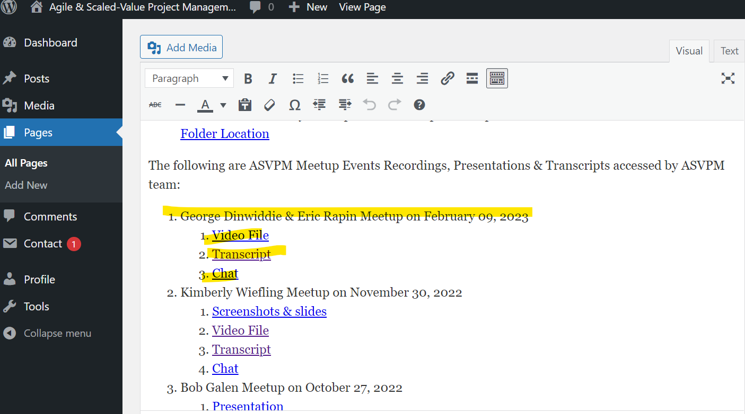

- Replace the links, by the link of where the new material is located by clicking on “edit link”

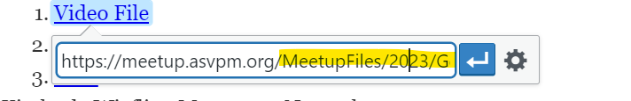
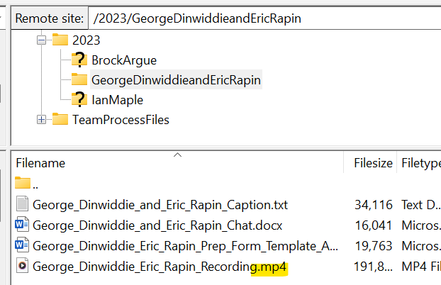

Please note, always save the recording file as “.mp4” so it opens in a new browser rather than being downloaded.

The links are done by using the path + the name of the document (remember to ensure there are no spaces)
Example: https://meetup.asvpm.org/MeetupFiles/Year/Folder_Name/Name_of_the_file
https://meetup.asvpm.org/MeetupFiles/2023/GeorgeDinwiddieandEricRapin/George_Dinwiddie_and_Eric_Rapin_Caption.txt
- Send an email to the speaker after the meetup thank him/her.
- Contact #hss group informing them all links are ready in the ASVPM Meetup Resources so the website can be updated with the new materials from the recent Meetup Session.

